Genetics Alumni Survey 2026

Current Graduate School Status* | Count (%)
Completed graduate school | 80 (49%)
Currently enrolled | 44 (27%)
Planning to apply in the future | 24 (15%)
None | 14 (9%)
*Graduate school includes all master's degrees or doctoral degrees (e.g., MD, DO, MD/PhD, PhD, DDS, DVM).

Highest graduate education attained or currently enrolled | Count (%)
Completed or enrolled: MD, DO, MD/PhD, PhD, DDS, DVM | 41 (25%)
Completed or enrolled: Master of Genetic Counseling | 29 (18%)
Completed or enrolled: Doctor of Biological or Life Sciences | 22 (14%)
Completed or enrolled: Master of Business and Science | 5 (3%)
Completed or enrolled: Other Master’s degree or not reported | 4 (2%)
Completed or enrolled: Master of Public Health | 4 (2%)
Completed or enrolled: Juris Doctor (J.D.) | 3 (2%)
Completed or enrolled: Master of Biotechnology | 2 (1%)
Completed or enrolled: RN/BSN | 2 (1%)
Completed or enrolled: Doctor of Biotechnology/Computational Biology | 1 (1%)
Completed or enrolled: Doctor of Education | 1 (1%)
Completed or enrolled: Doctor of Engineering or other applied science | 1 (1%)
Completed or enrolled: Doctor of Physical Sciences | 1 (1%)
Completed or enrolled: Doctor of Social Sciences | 1 (1%)
Completed or enrolled: Master of Bioethics and Science Policy | 1 (1%)
Completed or enrolled: Master of Biomedical Science | 1 (1%)
Completed or enrolled: Master of Business Administration | 1 (1%)
Completed or enrolled: Master of Counseling Psychology | 1 (1%)
Completed or enrolled: Master of Education | 1 (1%)
Completed or enrolled: Master of Medical and Clinical Science | 1 (1%)
Completed or enrolled: Master of Physician Assistant | 1 (1%)
Completed or enrolled: Master of Science in Health Informatics | 1 (1%)
Completed or enrolled: Other doctoral degree | 1 (1%)

Future graduate education | Count (%)
Not planning to attend graduate school | 14 (9%)
Future: MD, DO, MD/PhD, PhD, DDS, DVM | 7 (4%)
Future: Master of Genetic Counseling | 4 (2%)
Future: Master of Business Administration | 4 (2%)
Future: Doctor of Biological or Life Sciences | 2 (1%)
Future: Juris Doctor (J.D.) | 2 (1%)
Future: Undecided | 2 (1%)
Future: Master of Business and Science | 1 (1%)

Industry currently employed | Count (%)
Healthcare (e.g., medicine, dentistry, veterinary, and genetic counseling) | 71 (44%)
Biotech/Pharmaceutical | 26 (16%)
Graduate Student | 24 (15%)
Research/Science | 8 (5%)
Not Employed | 5 (3%)
Education: Higher Education (public or private) | 5 (3%)
Government & Public Administration | 4 (2%)
Education: Elementary, Secondary, or adult education | 3 (2%)
Financial Services | 3 (2%)
Law/Legal Services | 3 (2%)
Computer Science, Technology, Information Technology | 2 (1%)
Medical Technology | 1 (1%)
Business & Healthcare services | 1 (1%)
Retail/Wholesale trade | 1 (1%)
Social Sciences | 1 (1%)

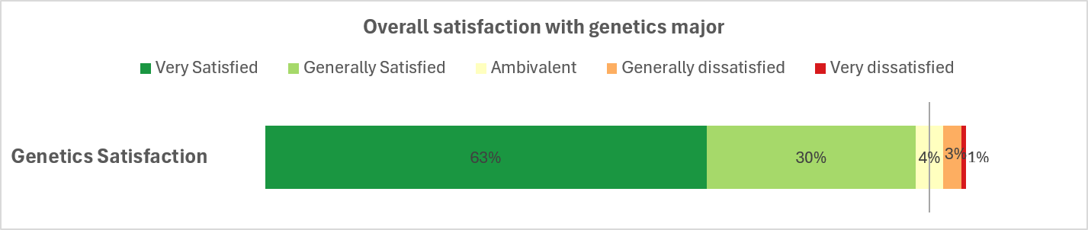

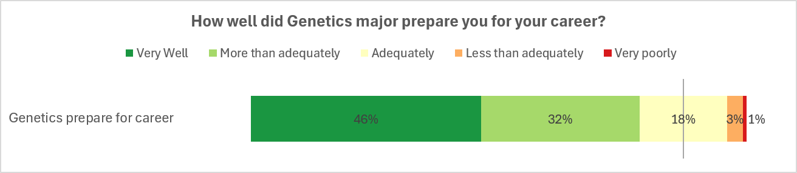

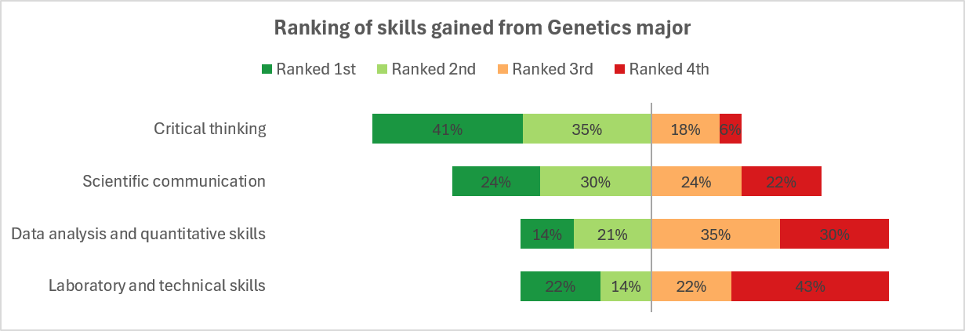

What would you tell a prospective student or parent about majoring in genetics?
Great major - more specialized than the typical biology degree. Genetics is really the future of medicine. Loved the electives options we had including ethics of genetics and communication skills in genetics. Was able to present a few posters thanks to this major and discover my passion for research!
I think the Genetics program at Rutgers was phenomenal. The overall university experience at Rutgers varies.
Helps you learn how to think. Helps you realize that there’s more that we don’t know in life, not everything can be found textbook. Rutgers Genetics was great. I went to medical school after. Decided I didn’t want to be a doctor. Worked in big pharma, but that wasn’t the problem I wanted to solve. Now I help people build financial freedom. Rutgers and more specifically this program helped me position myself to make 291+ people 20.2M+ in passive income
Choosing the genetics major at Rutgers was the best decision I ever made. Take advantage of all of the courses they have to offer and get involved in research as soon as you can! I loved my time at Rutgers!
The major at Rutgers is very research-based and prepares you well for a career in/around research. Initially it might seem like one needs an additional, advanced degree to qualify for a job in genetics, but there are jobs in the field requiring just the bachelor’s degree. I cannot praise enough how well the major prepared me for working in research/in a lab, particularly in science communication and lab skills; I still use the science communication techniques, poster templates, PowerPoint templates, and associated skills to this day, and it has served me very well to know how to explain technical science at a layman’s level, especially in working with a general patient population. Also, there was a benefit to the major being small- I became good friends with many of my fellow graduates (and fellow AUG members- the close association between the major and the club was great!)
Genetics opens up a lot of career paths and connections. You can go into research (PhD), medical school, pharmaceuticals, genetic counseling, or a science-adjacent field like scientific journalism, marketing/business for a medical company; etc. The professors and staff are very engaged and easy to collaborate with. I felt very supported as a Genetics major and it was a great experience. Shout out to Dr. Heiman for being an amazing mentor on the GC Undergrad Program!
Majoring in genetics has been a great experience overall. It has prepare some for many different aspects of my work even though it isn't research or even immediately related to the field of genetics. At Rutgers, the skills you learn from the staff and courses are invaluable. The faculty and staff are nice and wonderful to work with. The critical thinking skills, computer programming, day analysis, and communication skills learned are applicable to any field and have helped me greatly succeed in my path to law school.
Genetics is a rapidly growing and exciting field! There are so many paths a degree in genetics can lead you down, and I think the path from degree to career is more direct compared to some other life science degrees. I would encourage anyone with an interest in healthcare or the life sciences to consider majoring in genetics. The Genetics program at Rutgers did an excellent job of supporting and engaging with students in a personal way that feels unexpected at such a large institution. I had so many positive experiences with leadership, mentors, and faculty from the department, which made me feel valued and also taught me a ton - both about genetics and how to navigate the transition from student to career.
It provided me with the skills and experiences the prepared me for my current job.
The field is expanding rapidly and there's so much to study and learn - it's hard to get a job in academia but it's worthwhile to be able to contribute to medical research and the field itself makes you an eternal student. There's always something new to learn. I'm just so grateful. My professors were all people who really cared and were really passionate about the field. I feel lucky to end up where I did because I couldn't have asked for a better education for my field.
That passion for genetics should be a factor in the decision to pursue this major & to keep an open mind regarding future jobs. I did not know which job(s) I would pursue, but knew that I was passionate about genetics. I learned about the field of genetic counseling during my undergraduate degree, and am now a genetic counselor thanks to the Genetic Counseling Certificate Program. The major would adequately prepare any prospective genetic counselor for graduate school, as well as others passionate about other careers in Genetics.
Wonderful degree with small class sizes, personalized attention from advisors, and a lot of flexibility to customize a life sciences major to fit your academic and research interests I turned down an offer from an Ivy League institution to attend Rutgers on an academic scholarship. When I started my genetics degree, I wasn’t sure it was the right call. Almost 5 years out from graduating Rutgers, I am beyond certain that this was the best fit for me and I reached my professional goals faster and more prepared than if I had attended the other university. Other institutions didn’t have a specialized major just for genetics, focused advising, and all the opportunities and mentorship found in the genetic counseling certificate program. Without the certificate program, I wouldn’t have been prepared to apply to graduate school straight out of undergrad. I was prepared for the rigorous genetics courses and science communication skills from my time at Rutgers. Thank you!
Amazing professors, good research opportunities, really interesting coursework
The field is ever expanding and is not limited to one career path. There are so many avenues to explore with genetics and its constant evolution makes it so interesting.
Despite many professions being replaced with the use of AI, there are still many jobs available in biomedical or pharmaceutical sciences to geneticists. Having a genetics undergraduate education instead of a biology degree can help make your application for a job or graduate program more competitive.
The Genetics department at Rutgers is extremely supportive and encouraging to their students. The professors are truly wonderful, enthusiastic, and passionate about their science as well as engaging with the students. Rutgers is an enormous school where you learn to fend for yourself and take opportunities that come to you. As a student in Genetics I found the community helpful in both pushing their students to accomplish their goals and encouraging to ask questions and receive help. I enjoyed my time in the department.
I was a unique kid in that I've known since I was 16 that I wanted to study genetics and cancer. Rutgers genetics degree was one of the only options that gave me the opportunity to become an expert in this field in my first degree. Throughout this degree you have the opportunity to get a lot of 1 on 1 attention from the incredible professors because of the small class size, which also helps to make Rutgers smaller, in the best way. The degree is also arranged so that every student has many options of what to do after, and they're prepared for all possibilities whether that’s going to medical school, pursuing a graduate degree, or going to the industry. Overall, I loved my degree and feel that it perfectly situated me for what I'm doing now in my PhD.
It opens up a variety of lines for a student to pursue. For example, you can go into academia, medicine, genetic counseling, or even industry. Genetics is becoming a very important topic in medicine, and there is a lot of further scope in this field of study. I really liked the research requirement of the major. This made me look at the different types of research that is being done at Rutgers, which helped me realize my interests. I really enjoyed the major and I feel that majoring in genetics was the best decision of my life.
It is an excellent program with supportive faculty. Prepares you very well for medical school.
NETWORK. Talk to more than just your research mentor. I got opportunities after undergrad because people remembered me and my interests. Do the social events. Go to as many talks and dissertations as you can. You might not understand or be good at asking questions but the exposure is important. Lastly, LEARN TO PRESENT WELL. It will be crucial for any scientific or medical career you choose (or any career really). It is the most important skill I learned.
Majoring in genetics opens the door to many fields and allows students to attain a high level of understanding about biology and chemistry, possibly higher than in a more general major in which courses are more variable and don’t build on previously learned knowledge. As a medical student, having majored in genetics has given me a significant advantage in that I was already familiar with congenital diseases and cancer genetics at the beginning of my graduate education. I loved working with Dr. Sahota at the HGINJ and I hope that everyone there is doing well!
Majoring in genetics was awesome for a pre-medical student as it qualifies all the prerequisites and gave me so much research experience. I gained lots of extra helpful background knowledge through electives and loved the small classroom sizes. No complaints!
It was the best decision I made during my undergraduate career! The faculty are incredible, I learned a ton about a quickly developing and highly relevant field, and I was extremely well prepared for graduate school.
Beyond just the really cool science you are exposed to and participate in, you will learn a lot about yourself and be set for your career long term. The rigor of this program is equitable to extremely high-level career roles. Although I do not use my genetics degree in the way it was envisioned at graduation, the foundation and knowledge is incredibly useful in my day-to-day work
The Rutgers Genetics department is world class research with a neighborly feel. This department will teach you not only to do great science, but also be a great scientist.
The major exposes you to many different subfields involving genetics and will teach the skills needed for the job force/graduate education. There is a big emphasis on research, which will be beneficial for post-graduation.
I would tell a prospective student that genetics, beyond the science itself, builds your ability to think critically and look beyond what's immediately apparent. The courses are designed to teach you to see the bigger picture, for example, examining parental history to understand how genetic traits are inherited and expressed. That kind of reasoning grows into the complex, layered thinking that helps people succeed well beyond the classroom. For me, genetics built exactly this skill and helped fast-track my journey to where I am today.
Genetics is an evolving field and is increasingly relevant to a number of industries, including medicine and biotech. A genetics major positions you well to explore a multitude of career paths and is foundational to a higher degree in any of these pursuits. My genetics major allowed me to not only learn more about the career I ultimately chose (genetic counseling) but provided me with the prerequisites I needed to not just qualify for graduate school, but to also succeed. During my time at Rutgers, the genetics major was still smaller, which was great for me as someone who sought support of her fellow students and the variety of career opportunities that the major was able to provide- a rigorous but supportive environment.
Great major if you are interested in pre-med or research. The faculty are super nice and they give great advice and are very approachable. There are very interesting classes that dive into specific topics of genetics and prepare you for research and critical thinking.
The flexibility and depth of the material learned in the genetics major sets it apart from any other life sciences major. Anybody considering a graduate degree should be seriously considering the genetics major as it provides a fantastic background and experience to make it in the next level. Transferring from being a biochemistry major at SEBS to a genetics major at SAS was one of the best decisions I’ve ever made in my life. I’m eternally thankful to Rutgers and everyone in the genetics major for their help in preparation beyond university.
I'd tell them it's a major that adequately prepares you to participate in genetic research and provides you with high-quality training. It's a major that has a strong emphasis on scientific communication and thorough understanding of the science.
Can open doors and a conversation better than other similar majors. I think a beneficial part of the major could be a focus on applying to jobs and applying to whatever your next phase is while in your final year or final semester of the major. This would allow graduate to feel more confident in the next pursuit, post grad, and to concretely make steps towards their future, while having mentorship in that transition with faculty and staff of Genetics.
I referred many pre-med students because the wet lab training and research topic is great to speak about during interviews. The subject knowledge of genetics is very relevant to all medical students. I was an early student in the major.
Unique degree that gives more opportunities than other biological degrees I loved the classes and how they were relevant to real world and how good the professors were.
I would tell them that a degree in Genetics opens a world of opportunity. I would also encourage them to pursue a Masters or PhD in the field, in order to better leverage skills.
It was a wonderful experience, it opened opportunities to research which ultimately allowed me to see that medicine was what suited me the most and the coursework I did helped me prepare for the MCAT and ultimately helped with my medical courses in medical school.
It is a very small and tight-nit major, which I appreciated. The smaller class sizes allow you to get to know your classmates and your professors. The career panels were helpful to think about what you can do with your degree. Everyone was always very nice and supportive in the department.
Rapidly advancing field, directly appliable to many aspects of medicine, exposure to research, variety of career paths
It was an excellent major with many resources. I felt extremely supported as an undergraduate which can be difficult at a large university. I wouldn’t change a thing and would do it over again.
I loved the degree, don’t use it very often but it was interesting to study while also getting my premed requirements out of the way. Loved my genetics degree. Would do it again even though I didn’t end up in that career field.
Genetics is a great major that prepares the student for any future advanced scientific training and career. Thank you for an amazing experience! The smaller classrooms allowed for great personal growth as a student, great discussions and group study that allowed us to have a unique experience compared to the larger science majors.
If you are interested in genetics, and particularly research, the genetics major is a great option. It is a relatively small cohort, which fosters a community of students. And the professors and contents are interesting. I was originally pre-med, and don't think that the genetics major was the best fit for someone on that track; however, I ultimately was satisfied with the education and am pleased with the career I have today.
If you want to do life science as a career the Rutgers undergraduate Genetics major is a fantastic choice. It set me up to succeed and do well in grad school and my current industry role. Make sure that you join a lab in your Sophomore year though, the lab research experience is the most important part and it will let you apply the things you learn in class. Fantastic time, great professors, and the research opportunities were amazing. I'm truly grateful for my time there.
One of the biggest benefits of the major is the requirement for undergraduate study, which ensures all undergrads gain hands-on experience in a lab. While I am not currently working in the genetics field or in research, I found my hands-on experience in my undergrad research was incredibly valuable. I also believe that the effective communication skills in genetics course gave me the ability to best communicate scientific topics between departments. Additionally, the genetics of compulsive behaviors course I took helped a lot in learning how to dissect scientific writing and focus on what is actually being written.
Focus on critically thinking through the assignments. Network and seek advice from professors as well as pay attention in intro to courses to gauge what attracts you. Genetics is a vast field and intro courses give a good groundwork for all the different applications and subfields.
The requirements for the genetics major, specifically the research, was extremely helpful for me down the road. The genetics faculty members enjoy working with students and are a great resource. I have no regrets about my major, and am very satisfied with my decision to be a genetics major.
The Genetics program at Rutgers was incredibly unique because it took a step away from multiple-choice-based testing and instead forced us to create thoughtful explanations for experimental design and outcomes. The mandatory research component also developed students' resumes and prepared us for research environments outside of the university. I highly recommend it to any student interested in a career in research, who wants to get their hands wet in the lab. You were the best of the biology programs at Rutgers when I attended, and I am sure you still are! I wish the whole department unending luck both as researchers and instructors.
There are a lot of transferable skills to many different industries. The opportunity to do undergraduate research will set you up for success in ways that go beyond just the technical skills (which are also very valuable!). You’ll get skills that will get you in the door and skills that will help you build a career. My genetics major prepared me for my first job after college and gave me the foundational skills I needed to successfully transfer from academia into pharma when my plans changed. One of the most valuable skills I use in my day-to-day is critical decision-making using complex interconnected data. Thinking about a problem from multiple angles rather than jumping to the first obvious conclusion, and recognizing when I need more information to truly understand a problem are skills I learned in classes and experienced firsthand being involved in undergraduate research. The requirement of needing undergraduate research to graduate in the genetics major was one of the best things that prepared me for the workforce and set the trajectory for my career. Thank you.
It's a challenging major and it sets you head-and-shoulders above your peers in feeling prepared and capable for the workforce. It was my favorite part about Rutgers!

